Market Monitor - Somalia - 2026-05

Highlights
Food prices in Somalia continued to rise sharply in May 2026, with significant month-over-month and year-over-year increases observed across all monitored staple commodities. The cost of the national average food basket increased by 6.9% compared to the previous month (↑6.9% MoM) and is 22.1% higher than the same time last year (↑22.1% YoY).
The increase was driven by sharp price hikes in key staples, particularly imported rice (↑11.4% MoM; ↑37.8% YoY), cowpeas (↑8.9% MoM; ↑30.0% YoY), and white sorghum (↑7.7% MoM; ↑14.3% YoY).
Key Drivers:
- Widespread monthly price increases were recorded for all food basket commodities, indicating broad inflationary pressure.
- Imported rice experienced the most significant price surge, rising 11.4% in one month, making it a primary driver of the overall food basket increase.
- Substantial year-over-year inflation continues to affect household purchasing power, with prices for essential staples like cowpeas and white maize remaining significantly elevated (+30.0% and +25.2% YoY, respectively).
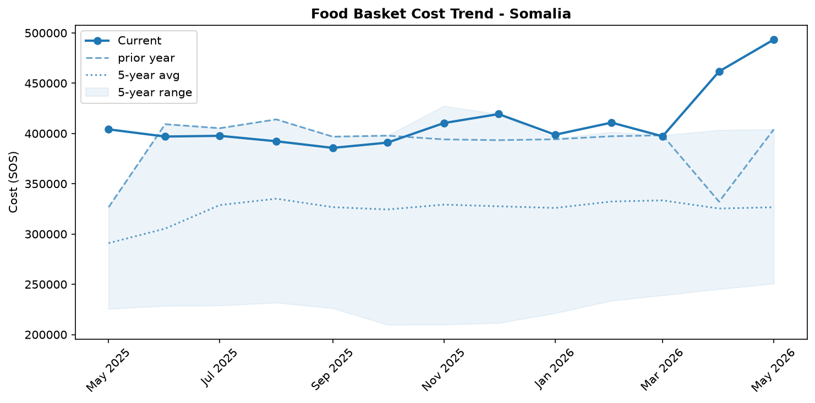
Food basket cost trend

Market Overview
Market conditions in Somalia deteriorated significantly in May 2026, marked by broad-based and accelerating food price inflation. The cost of the national food basket surged by 6.9% month-over-month and a staggering 22.1% year-over-year, severely straining household purchasing power. This inflationary pressure is occurring despite the continued stability of the Somali Shilling, indicating that factors other than currency depreciation—such as supply constraints or rising global commodity costs—are driving the increases. The trend is led by sharp price hikes in essential imported staples, particularly rice, alongside locally produced cereals. While one report noted improvements in household food consumption scores, this is sharply contradicted by the quantitative price data and other on-the-ground indicators. Reports of rising child malnutrition and a credible famine risk in certain areas (Event SOM-004, SOM-005) align more closely with the severe market pressure. Given the widespread and accelerating price increases across all monitored commodities, food affordability is expected to worsen in the near term, deepening the country's complex humanitarian crisis.

Commodity Analysis
An analysis of individual commodities reveals that inflationary pressures are both widespread and acute for key staples. Imported rice was the primary driver of inflation, experiencing the most significant price surge with a double-digit monthly increase of 11.4% and the highest annual inflation at 37.8%. Cowpeas followed closely, with prices rising sharply by 8.9% month-over-month and 30.0% year-over-year, indicating strong demand or significant supply constraints. Locally produced cereals also faced substantial price hikes. White maize, a critical staple, saw its price climb 5.3% from the previous month and 25.2% over the year. White sorghum prices accelerated notably this month by 7.7%, a concerning trend despite its more moderate annual inflation of 14.3%. Other basket items contributed to the rising cost of living, though to a lesser extent. Imported vegetable oil prices rose 4.5% month-over-month (21.3% YoY), while sugar increased by 5.5% month-over-month but had the lowest annual inflation at 9.5%. In contrast, imported wheat flour showed the most modest monthly increase at 1.5%, suggesting some relative short-term stability, though its annual inflation remains in double digits at 10.3%.
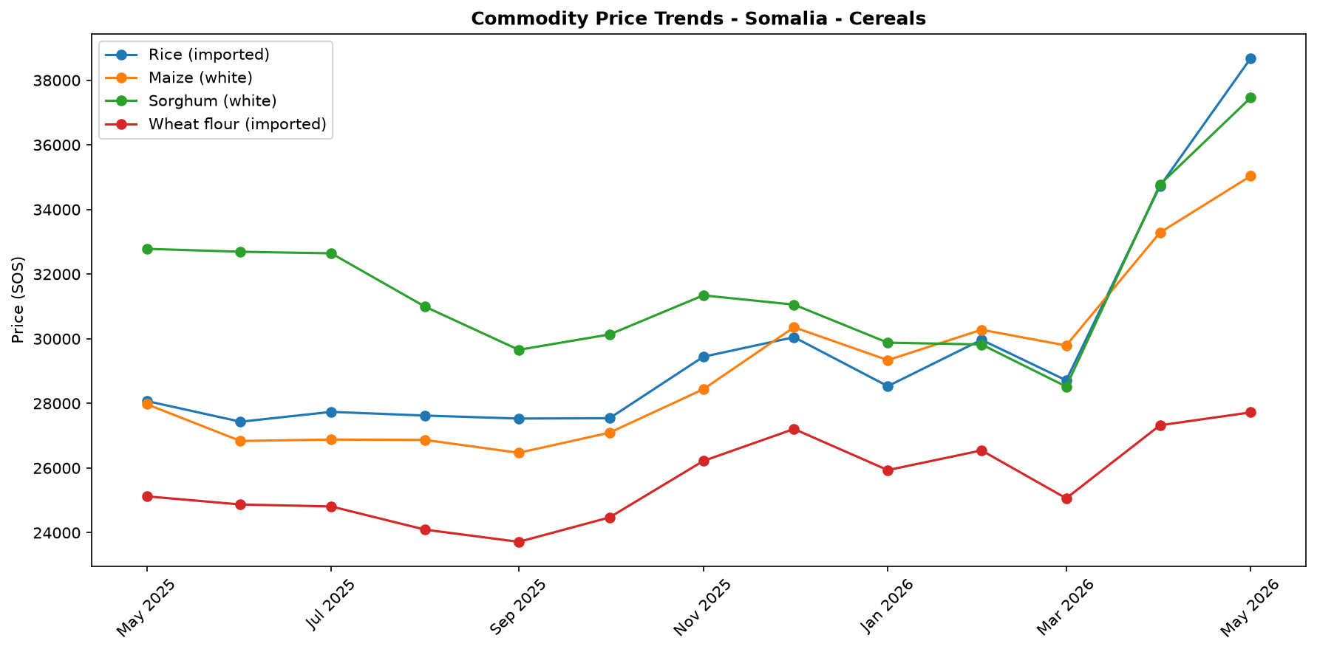
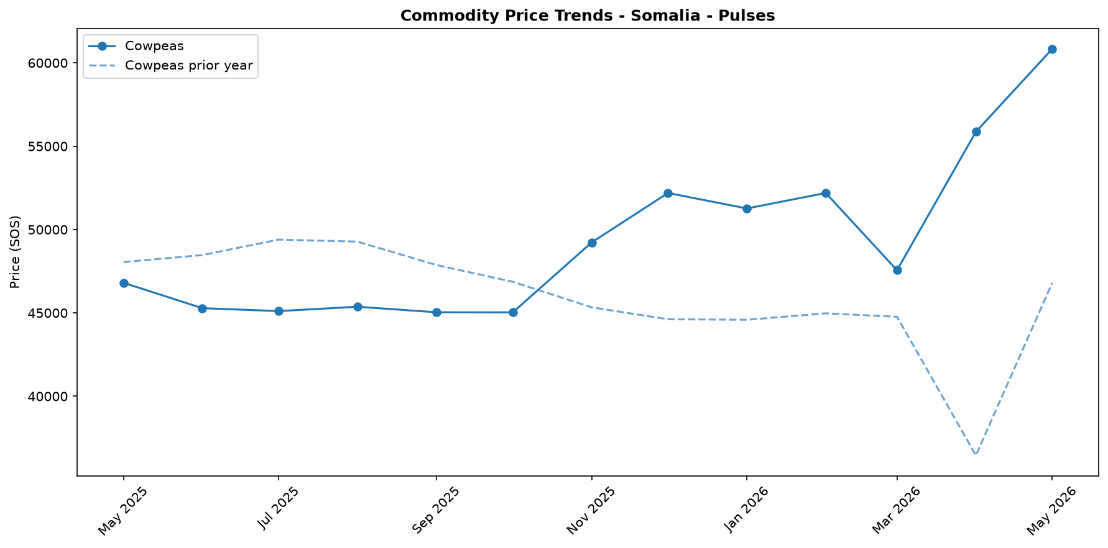
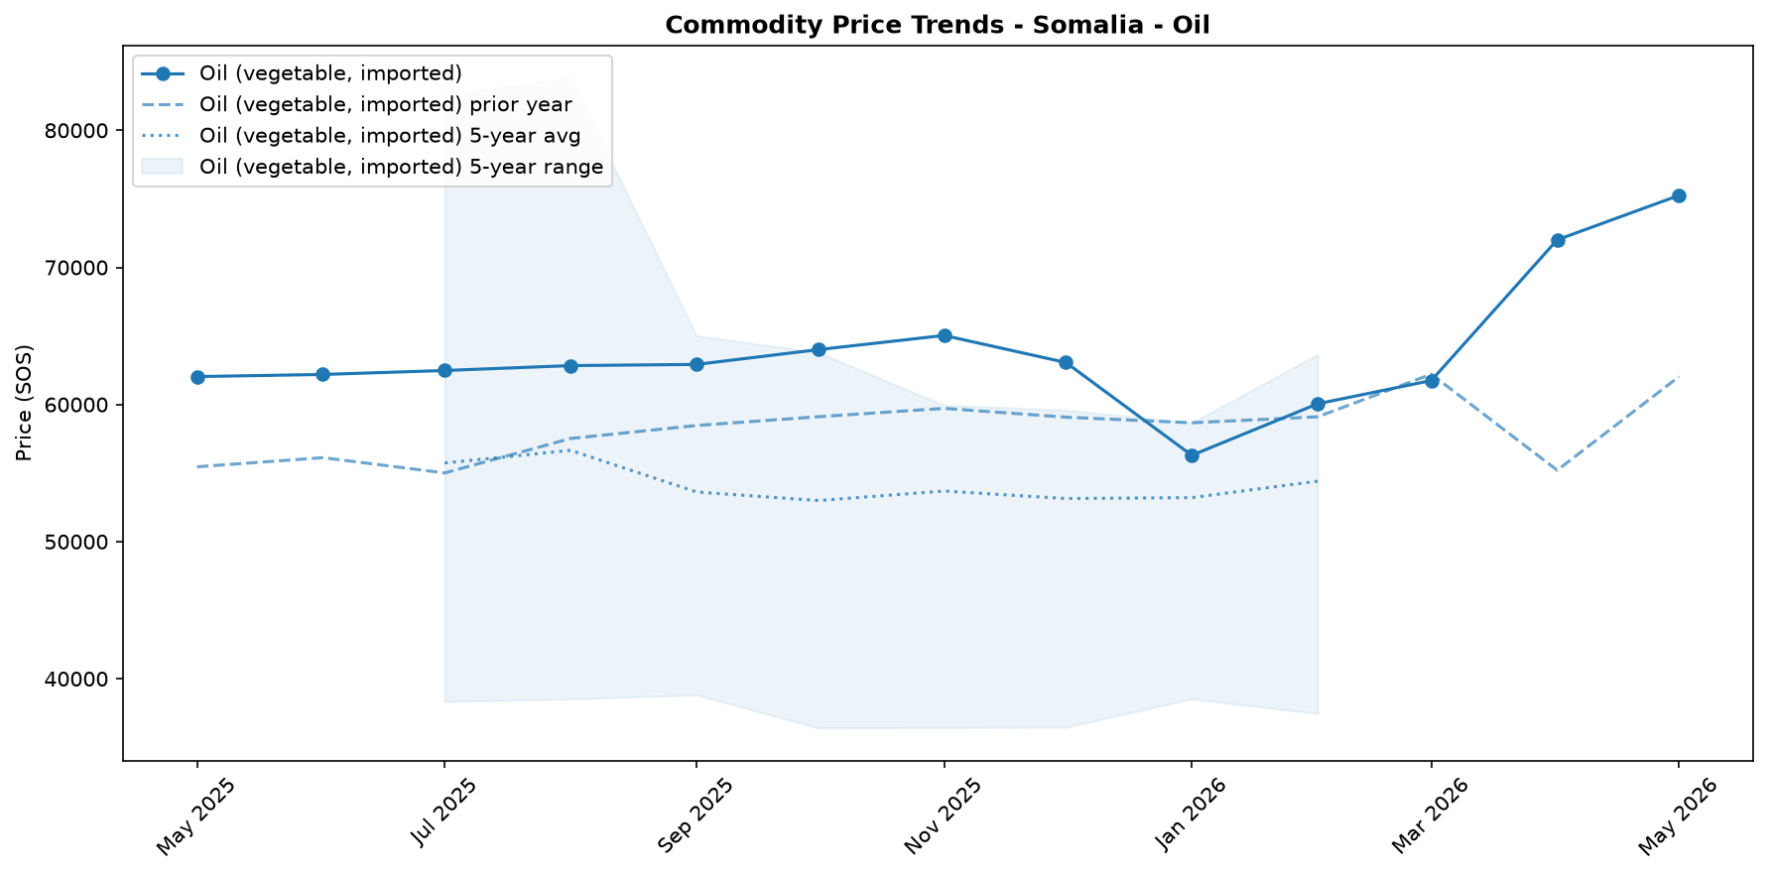
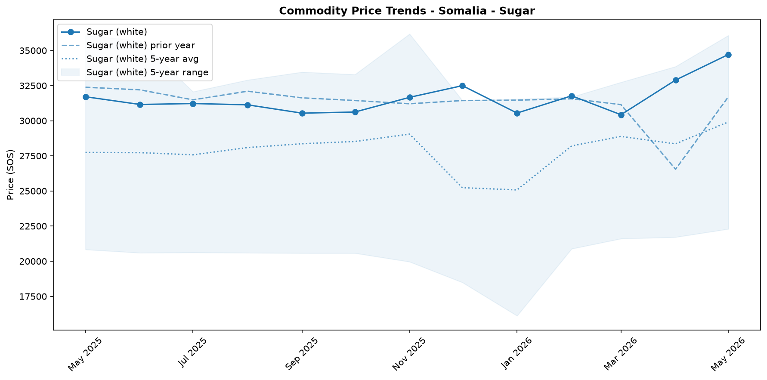

Regional Highlights
While national data illustrates a concerning trend of rising food prices, the impact is felt most acutely in specific regions, creating pockets of extreme vulnerability. A recent Integrated Food Security Phase Classification (IPC) analysis highlighted a particularly dire situation in Burhakaba District, which faces a credible risk of famine (Event SOM-004). The national price surges for staple foods are likely a major contributing factor to this localized crisis. The significant annual inflation of key staples consumed in the region, such as white maize (+25.2% YoY) and sorghum (+14.3% YoY), is severely eroding the purchasing power of already vulnerable households. This economic pressure is corroborated by humanitarian indicators, including reports from Action Against Hunger of a significant rise in admissions of severely malnourished children to its stabilization centers across the country (Event SOM-005). The crisis in Burhakaba underscores how national market volatility translates into life-threatening consequences at the local level.
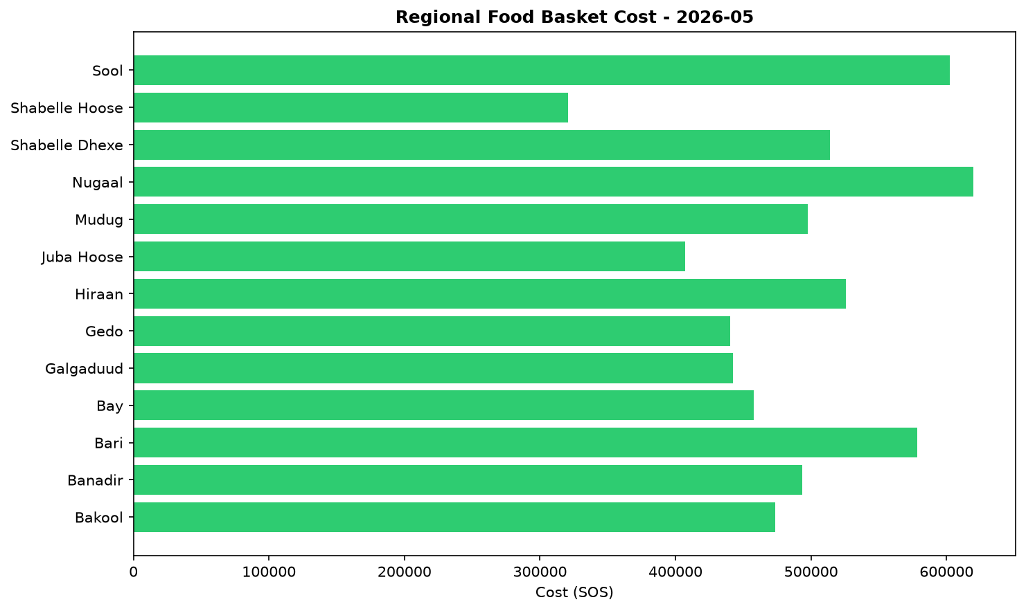

Exchange Rate Analysis
The Somali Shilling (SOS) remained stable against the US dollar, trading at an average of 571.5 SOS per USD. The exchange rate recorded a 0.0 percent change compared to the previous month, indicating continued stability that helps prevent an increase in the cost of imported goods due to currency fluctuations. On a year-on-year basis, the rate also showed no change, highlighting a prolonged period of steadiness that provides a predictable environment for international trade. This sustained stability is crucial for food security, as it helps to contain domestic price increases for key imported commodities like wheat, rice, cooking oil, and fuel. While global market dynamics can still influence local prices, the lack of currency depreciation means the exchange rate is not currently an additional driver of food price inflation in Somalia.

References
- [rw_4214041] ReliefWeb (2026-05-29) Somali Cash Consortium – Baseline and Endline Findings MPCA Outcomes from the Direct Nutrition Referral Approach: Gedo & Banadir regions, Somalia (November 2025)
https://reliefweb.int/node/4214041
- [rw_4213907] ReliefWeb (2026-05-28) Somalia: Emergency and Resilience Plan, 2026–2028
https://reliefweb.int/node/4213907
- [rw_4213862] ReliefWeb (2026-05-28) World Hunger Day: Urgent global action needed as hunger doubles in a decade
https://reliefweb.int/node/4213862
- [rw_4213744] ReliefWeb (2026-05-26) Somalia Faces Deepening Hunger Crisis as Risk of Famine Emerges in Burhakaba
https://reliefweb.int/node/4213744
- [rw_4213683] ReliefWeb (2026-05-26) Somalia: Diphtheria Outbreak - DREF Final Report (MDRSO024)
https://reliefweb.int/node/4213683
- [rw_4213549] ReliefWeb (2026-05-25) WFP Somalia Country Brief May 2026
https://reliefweb.int/node/4213549
- [rw_4213533] ReliefWeb (2026-05-25) Sexual Exploitation and Abuse (SEA) Joint Risk Assessment for Somalia - February 2025
https://reliefweb.int/node/4213533
- [rw_4213456] ReliefWeb (2026-05-25) Somalia Weekly Weather Forecast - Valid From 21 to 27 May 2026
https://reliefweb.int/node/4213456
- [rw_4213396] ReliefWeb (2026-05-24) Somalia - ARC Drought Insurance Payout Activation Bulletin: 2025–26 Deyr Season (May 2026)
https://reliefweb.int/node/4213396
- [rw_4213288] ReliefWeb (2026-05-22) Radio Ergo Weekly Feedback Report, Issued: 22 May 2026
https://reliefweb.int/node/4213288
- [seerist_1028776] Seerist (2026-05-29) Global maritime outlook: June 2026
- [seerist_1028721] Seerist (2026-05-27) Big Picture series: Carbon markets in Sub-Saharan Africa – growing opportunities amid regulatory, integrity challenges
- [seerist_1028607] Seerist (2026-05-19) Big Picture series: France’s push into anglophone Africa to bring new commercial opportunities despite West African controversies
- [seerist_1028580] Seerist (2026-05-18) Substantial ransoms to remain feature of Somali piracy following reported USD 10m demand
- [seerist_1028391] Seerist (2026-04-30) Global maritime outlook: May 2026
- [seerist_1028308] Seerist (2026-04-24) Local resistance, external pressure likely to undermine federal push to remove Jubaland administration
- [seerist_1028144] Seerist (2026-04-14) Big Picture series: Strait of Hormuz disruption to drive acute fiscal, supply chain challenges in Africa

